Half Yearly Progress Report on Research Work carried out from 28.09.2016 to 27.03.2017
Name and address of the candidate : P. Mohandass
Reg. No. P8851
PG and Research Dept. of Chemistry
Saraswathi Narayanan College
Madurai-22.

Occupation if any and address : Associate Professor of Chemistry
Saraswathi Narayanan College
Madurai-22.

Name, designation and address of the : Dr. K. Radhakrishnan
Guide Associate Professor of Chemistry
Saraswathi Narayanan College
Madurai-22.

College where the candidate carried : PG and Research Dept. of Chemistry
out the research Saraswathi Narayanan College
Madurai-22.

Whether the candidate has paid annual
Research fee (mention amount, date of : No
remittance, place of bank, etc.)

Detailed one page report on the progress : Separate sheet Attached
of research work carried out by the
candidate (attach separate sheet)

Remark, if any by the guide : Nil

Signature of the candidate Signature of the research supervisor

Half Yearly Progress Report on Research Work carried out from 28.09.2016 to 27.03.2017
The applicability of the LFER to cyclic voltammetry is being examined in the present investigation. Therefore, measurements of the electrochemical parameters of (E)-1-(furan-2-yl)-3-phenylprop-2-ene-1-one have been made by using cyclic voltammetry technique.
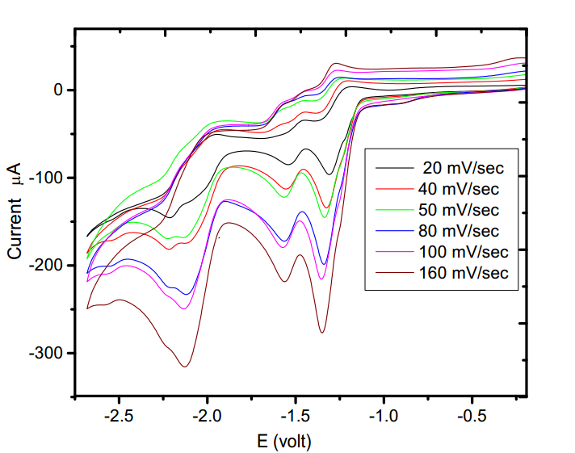
Figure (1)
Typical cyclic voltammograms at various sweep rates and at constant concentration (10 mM) of (E)-1-(furan-2-yl)-3-phenylprop-2-ene-1-one in acetonitrile is shown in Figure (1). In all the above cases, two well-defined voltammetry peaks are observed in the potential region -1.309 to -1.348 V and -1.543 to -1.563 V.

Signature of the research supervisor

